EXPLORE SCOTLAND

Task 3: Website Testing and Evaluation Report
Student name: __________________________________
Student number: ________________________________
Module: COM4014
Date: 29 October 2026

Evidence-based summary of responsive layout, HTML/CSS validation, and accessibility checks.

1. Introduction
This report records testing evidence for the Explore Scotland tourism website. The website contains seven pages: Home (index.html), Destinations, Culture, Accommodation, Travel Guide, Activities and Contact. The Contact page includes an enquiry form. Testing considered page layout at different viewport sizes, HTML and CSS validation, accessibility scan results, and the available cross-browser observations.
The report distinguishes results directly shown in the supplied screenshots from checks that still need additional evidence. An automated checker result applies only to the file that was checked; it does not prove that every page or every accessibility requirement passes.

2. Responsive layout and usability
The supplied desktop, tablet and mobile screenshots show the homepage adapting to different viewport widths. At desktop size, the site uses a horizontal navigation bar and multi-column content cards. At narrow/mobile size, navigation wraps across two lines and the hero heading, text and call-to-action remain visible. The supplied Culture, Travel Guide, Accommodation, Activities and Contact screenshots also show content arranged for narrow screens. The Contact form displays labelled fields in a vertical layout.
These screenshots support a visual responsive-layout check. They do not, by themselves, confirm that every interactive control works or that the enquiry form successfully submits. Those behaviours should be checked manually in the running site.
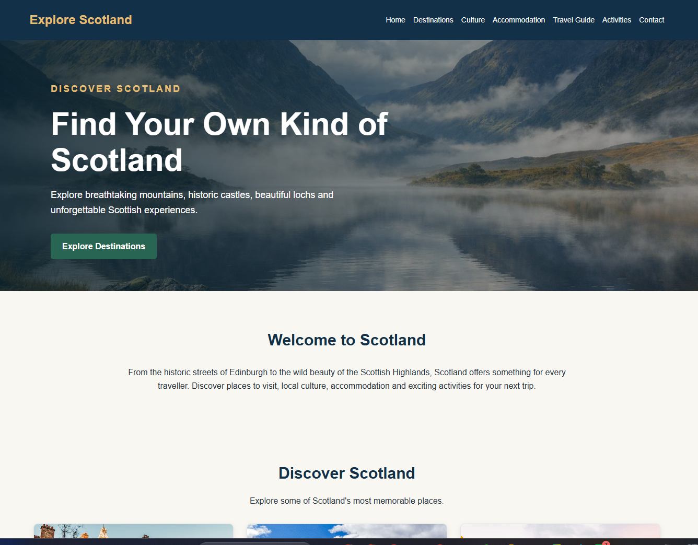
Figure 1. Homepage displayed at desktop viewport.
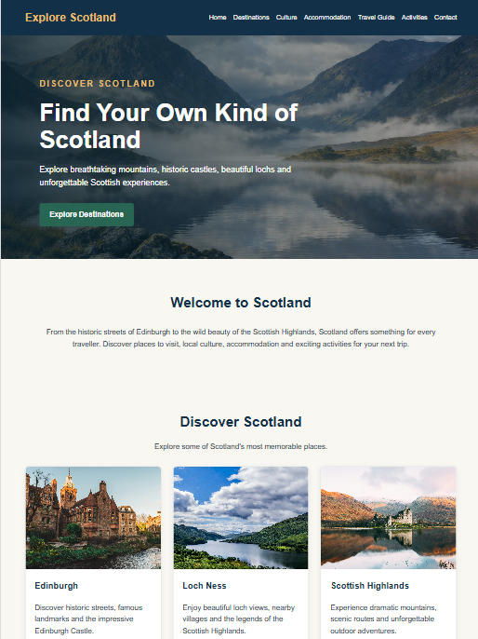
Figure 2. Homepage displayed at tablet viewport.
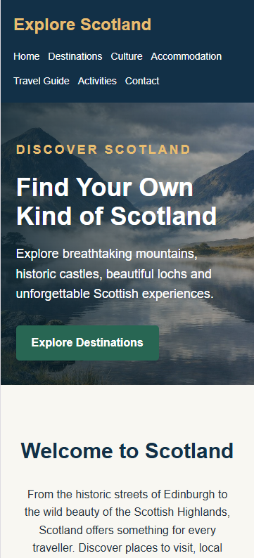
Figure 3. Homepage displayed at mobile viewport.

3. HTML validation
The supplied Nu Html Checker screenshots report “Document checking completed. No errors or warnings to show” for the files listed below. These are positive results for the specific uploaded files shown in the screenshots.
File shown in validator | Recorded result | Evidence / note
index.html | Pass — no errors or warnings | Nu Html Checker screenshot supplied.
destinations.html | Pass — no errors or warnings | Nu Html Checker screenshot supplied.
accommodation.html | Pass — no errors or warnings | Screenshot heading shows accommodation.html.
activities.html | Pass — no errors or warnings | Nu Html Checker screenshot supplied.
contact.html | Pass — no errors or warnings | Nu Html Checker screenshot supplied.
travel.html | Pass for the uploaded file shown | The screenshot says travel.html; the website source package names this page travel-guide.html. Confirm that the validated file is the same final page before claiming travel-guide.html passed.
culture.html | Not evidenced in the supplied validator screenshots | Run the Nu Html Checker on culture.html and save the result before final submission.
The source package contains seven HTML pages. The evidence currently includes clear validation screenshots for five matching page filenames plus a screenshot labelled travel.html. The Culture page validation result is not present in the supplied screenshots, and the travel filename differs from the filename in the source package. These two items should be resolved to make the HTML evidence complete.

HTML validation screenshots
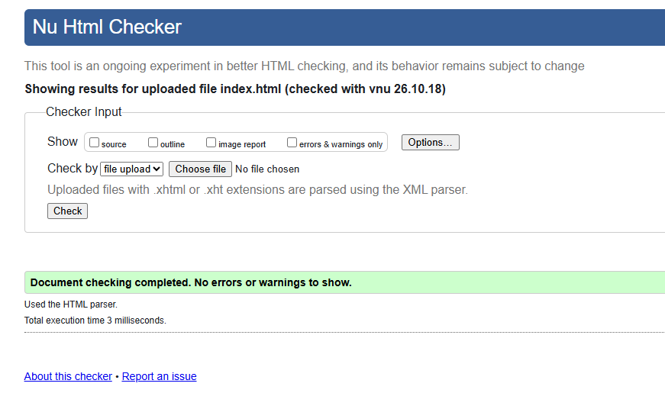
Figure 4. Nu Html Checker result for index.html: no errors or warnings.
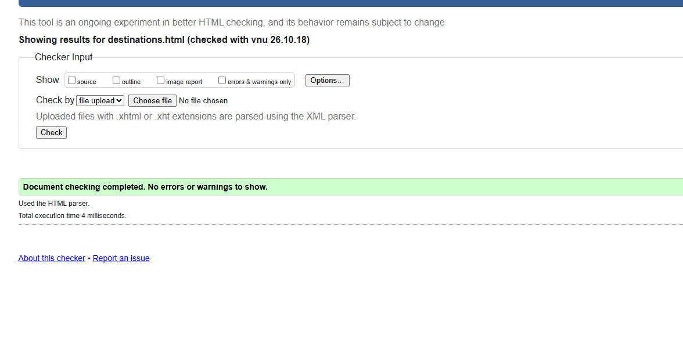
Figure 5. Nu Html Checker result for destinations.html: no errors or warnings.
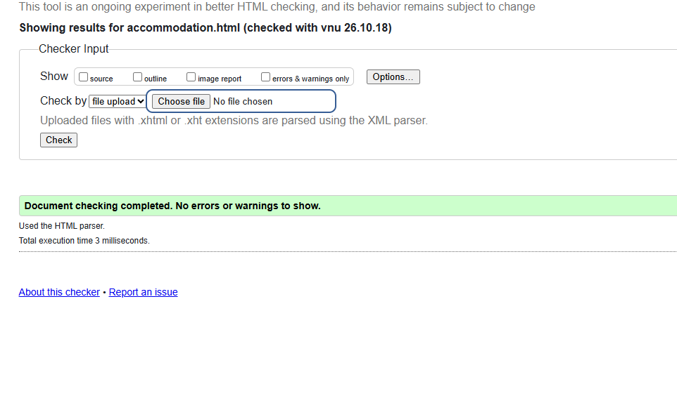
Figure 6. Nu Html Checker result for accommodation.html: no errors or warnings.
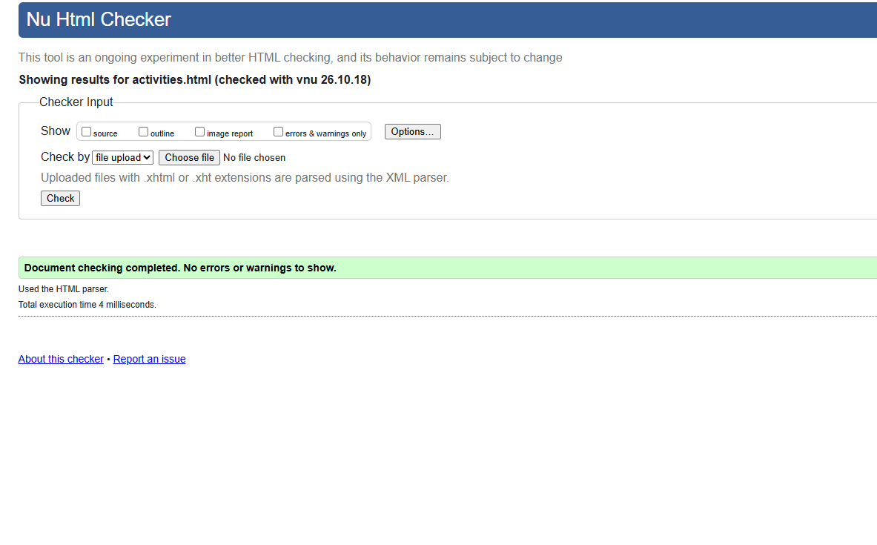
Figure 7. Nu Html Checker result for activities.html: no errors or warnings.
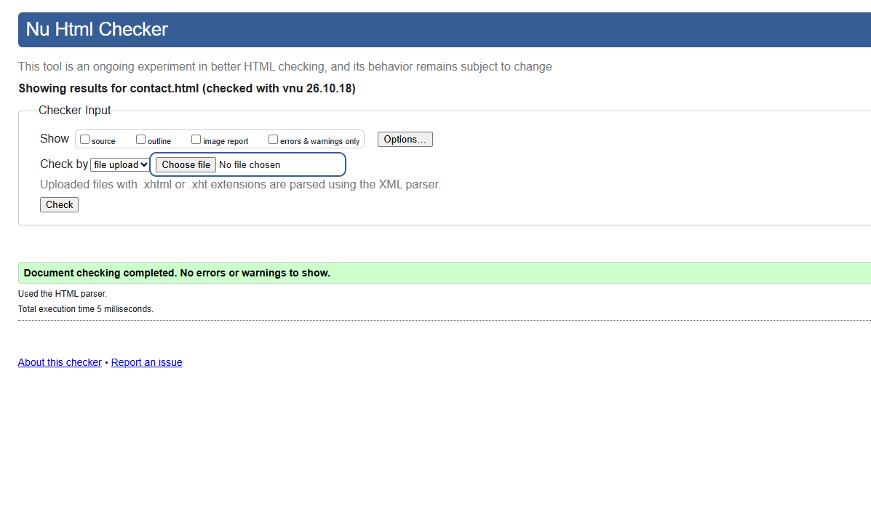
Figure 8. Nu Html Checker result for contact.html: no errors or warnings.
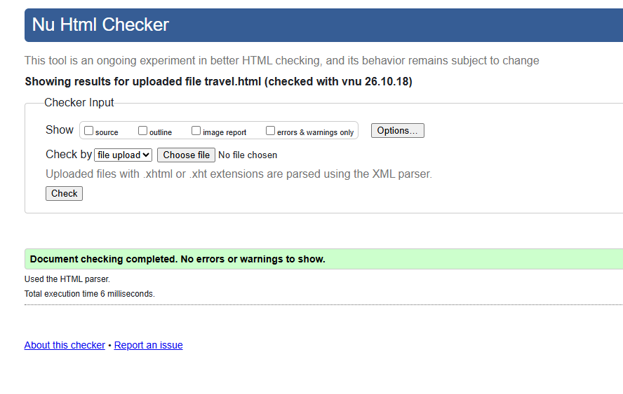
Figure 9. Nu Html Checker result for the uploaded file named travel.html: no errors or warnings.

4. CSS validation
The supplied W3C CSS Validation Service screenshot for style.css states “Congratulations! No Error Found” and indicates that the stylesheet validates as CSS Level 3 + SVG. A separate Nu Html Checker screenshot also reports no errors or warnings for the uploaded style.css file. The W3C CSS Validator result is the primary evidence for CSS conformance.
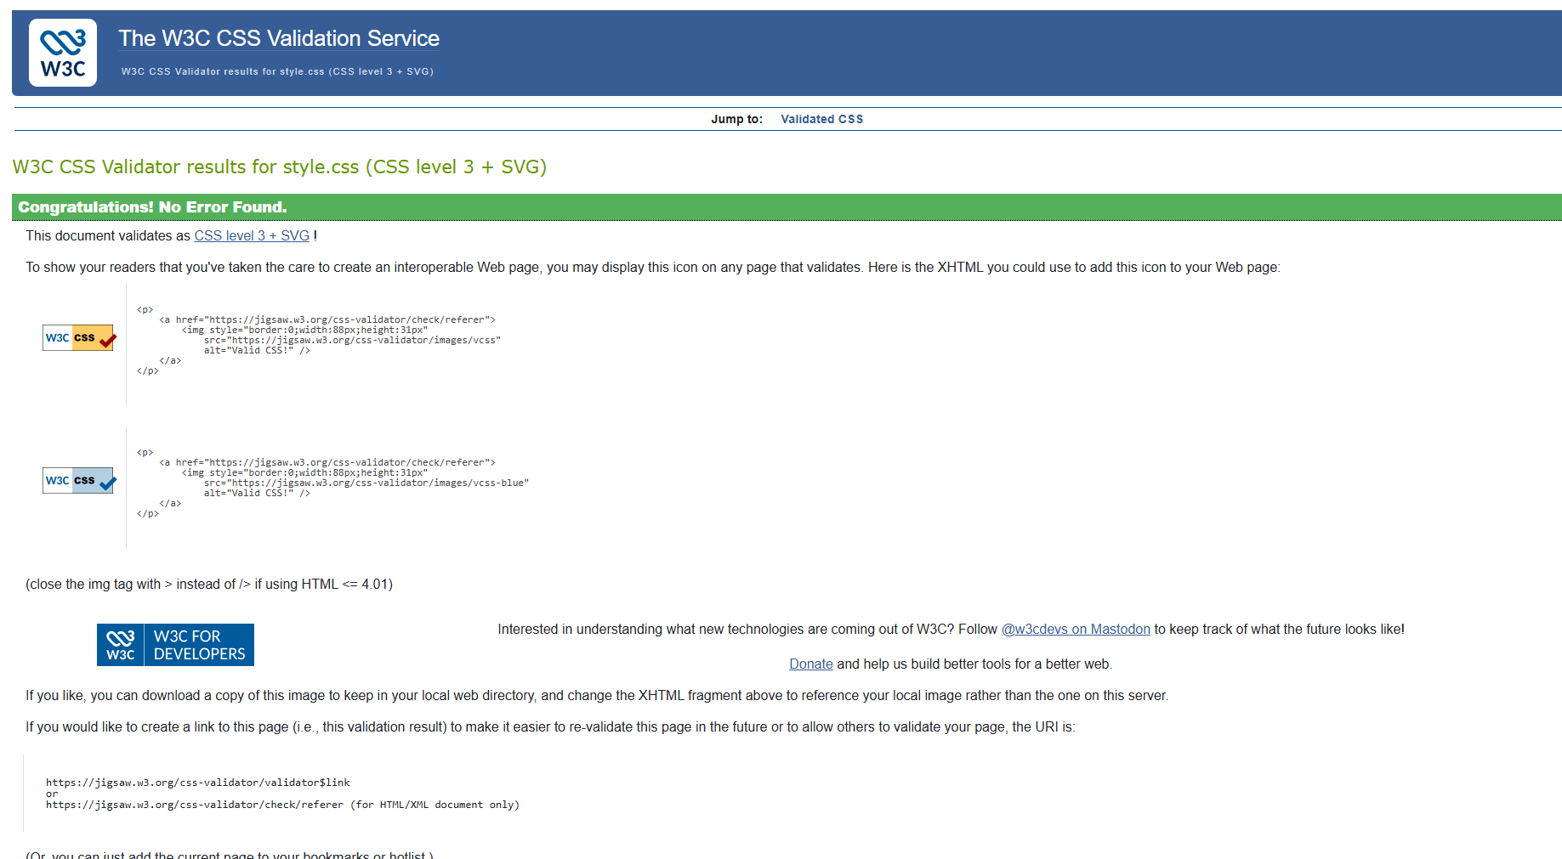
Figure 10. W3C CSS Validation Service result for style.css: no error found.
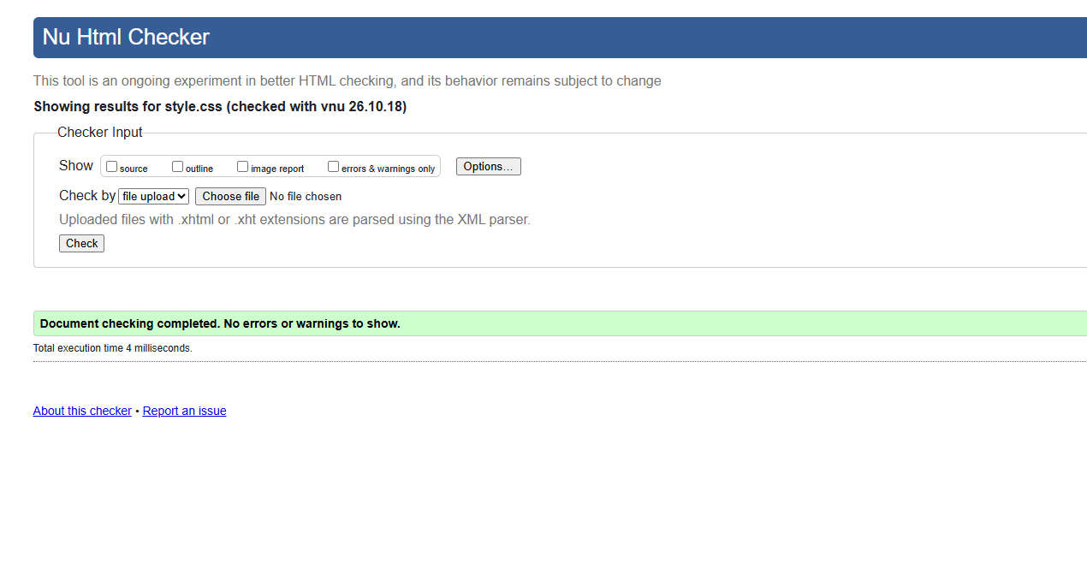
Figure 11. Additional checker result for style.css: no errors or warnings shown.

5. Accessibility evaluation
The supplied WAVE summary reports 0 errors, 0 contrast errors, 4 alerts, 4 features, 12 structure items, 0 ARIA items, and an AIM Score of 9.9 out of 10. The zero-error result is encouraging, but the four alerts require manual review. An automated scan and score do not establish full compliance with WCAG.
Recommended manual checks are: keyboard-only navigation and visible focus; meaningful alternative text for informative images; heading order; form labels and required-field messages; and whether the enquiry form can be completed and submitted using a keyboard. Review each of the four WAVE alerts individually and record whether it requires a correction or is an acceptable item.
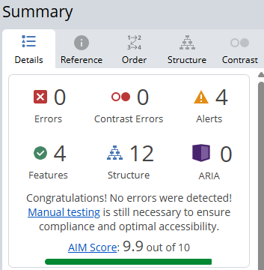
Figure 12. WAVE accessibility summary: 0 errors, 0 contrast errors and 4 alerts requiring manual review.

6. Cross-browser and functional checks
The project notes report that the pages and navigation were opened in Chrome, Microsoft Edge and Firefox, and that the pages were working. The screenshots supplied here do not independently identify the browser used for each test. If cross-browser testing is part of the marking evidence, include one labelled screenshot from each browser, showing the browser identity and a representative page.
The Contact page screenshot confirms that the enquiry form fields are present and visually arranged for mobile use. The supplied evidence does not demonstrate a successful submission, validation messages for missing or malformed input, or the handling of a submitted enquiry. These behaviours should be tested and recorded separately if required by the specification.

7. Test summary and outstanding actions
Test area | Current evidence-based status | Action needed
Responsive layout | Desktop, tablet and mobile screenshots supplied | Retain screenshots with clear device/viewport labels.
HTML validation | Five matching page files show no errors/warnings; travel.html also shows no errors/warnings | Validate culture.html and confirm travel.html vs travel-guide.html.
CSS validation | W3C CSS Validator reports no errors | No further action indicated by supplied CSS result.
Accessibility | 0 errors, 0 contrast errors, 4 alerts; AIM score 9.9/10 | Manually review and document all four alerts and key keyboard/form checks.
Cross-browser | User reports site works in Chrome, Edge and Firefox | Add browser-labelled screenshots if required by rubric.
Contact form | Form layout is visible in screenshot | Test field validation and submission; do not claim successful submission without evidence.

8. Conclusion
The evidence shows that the Explore Scotland website has been checked at desktop, tablet and mobile viewports. The submitted Nu Html Checker screenshots show no errors or warnings for index.html, destinations.html, accommodation.html, activities.html, contact.html and the uploaded file named travel.html. The W3C CSS Validator reports no CSS errors. WAVE reports no errors or contrast errors, while four alerts remain for manual review. Before treating Task 3 testing as complete, validate culture.html, confirm the travel-page filename, review the WAVE alerts, and add browser-specific or form-behaviour evidence if required.

References
World Wide Web Consortium (W3C) (n.d.) Nu Html Checker. Available at: https://validator.w3.org/nu/

World Wide Web Consortium (W3C) (n.d.) CSS Validation Service. Available at: https://jigsaw.w3.org/css-validator/
WebAIM (n.d.) WAVE Web Accessibility Evaluation Tool. Available at: https://wave.webaim.org/
World Wide Web Consortium (W3C) (2023) Web Content Accessibility Guidelines (WCAG) 2.2. Available at: https://www.w3.org/TR/WCAG22/

